October 25, 2024

Friends and Family,

We hit the ground running after returning from the States as I began teaching two classes for our Bible school. When we returned the students had already arrived and had taken several classes, so I immediately began teaching Acts and Church History. Each time I teach through these classes new things stand out and students react differently. We had an interesting discussion over Acts 15, where we were examining the four commands that the gentiles were expected to obey. One of these is avoiding the meat of strangled animals. I commented on how normally when someone butchers an animal they drain the blood out of the body whether it is a chicken, goat, or something else. One of the students then asked, “What about rats?” I wasn’t sure what he was asking, so I asked him to clarify. He explained that they normally go into the woods and set mouse traps to catch rats and then they come back after a few hours to see how many they have caught. Basically, rat traps don’t drain the blood, so is that the same as eating the meat of strangled animals? The amount of interest in the room and the fact that I have been served rat on numerous occasions showed me that this was a serious question for them! Since I was at a loss for how to answer this exactly, I recommended they each talk to their church elders about this and submit to whatever they decided.

Teaching through Church History was also interesting because many of the students have very limited exposure to churches, mainly Roman Catholic and Pentecostal denominations. We watched videos of different worship services in various denominations and made comparisons. The Orthodox churches of the Middle East always make an impression, because many of their practices were later adopted by Islam. It is odd for Mozambicans to see men wearing robes and large crosses with long beards kneeling or reading the Bible in Arabic, in a way that sounds very much like the way Muslims do. For many of the brothers, they think that kneeling is a Muslim way to pray or that everything Muslims do should be rejected because it is not Christian; the truth is that much of Islam was borrowed from Christianity. It is fun to talk through what elements are cultural and what are Biblical.

We ended the semester with our “Timothy Project” class where students report on their practicums. It is always encouraging to hear them share about how new churches were planted, children’s programs were begun, or visitation programs were developed in their local churches. Sometimes there were difficulties, like when a group from one church went to visit members who hadn’t been to church in a long time. They would arrive and find the person drunk and would have to come back at another time and urge them to come back to the church. While some of these visits were discouraging, many of them bore fruit and a number of people have repented and come back to the Lord. We ended our time with a graduation ceremony and we celebrated 18 new graduates. We had a big party, which in Mozambique means: cokes, goats, and cake. Thanks to Amy’s hard work we had plenty of cake! It was fun to celebrate how these students dedicated themselves to their studies. We were blessed to have as our guest speaker brother Estevão Campama, a minister and a member of the Lomwe Bible Translation Team. One of them asked me afterwards if we would be teaching more advanced classes for those who already graduated because they want to keep learning!

Several weeks ago Mozambique held elections for a new president and their parliament. Seats in parliament are decided by the percentage of votes that each party gets for president. During and after the election multiple accounts of fraud were reported which cast doubt on the validity of the results. Results were not reported for about two weeks. Last weekend one of the candidates’ lawyers was shot and killed. The results were finally announced yesterday evening and claimed that the ruling party had gained 70% of the vote and won in all ten provinces. This means they now have control of 70% of the parliament and can pass any legislation they want (even changing the constitution). I realize that there is talk of voter fraud in the USA, but this is at a completely different level. Imagine hearing that Democrats won a slim majority in Wyoming or Republicans won a slim majority in Massachusetts, or that one party did so well in the election that they have the ability to change the constitution. Today there were protests in cities all over Mozambique regarding the results. This afternoon we heard about 50 gunshots over the course of an hour as police were shooting to disperse crowds of protesters. We stayed at home and waited things out. I was really glad that I had built my house with three foot thick mud walls! All the cell phone networks’ internet quit working , but thankfully we were able to stay in communication since we recently got Starlink internet. We decided to cancel any travels outside of the city for the next few days as a precaution. One friend said he feels “enslaved” after 49 years of the same party in power, and another friend said that things will only change through a coup or civil war. We don’t know what is going to happen moving forward, but things seem to have mostly returned to normal for the time being. Whatever happens, we hope that we can continue to serve the Lord here and be examples of love and faithfulness.

Next week I was invited to speak at a large church conference in the Nampula province. Lord willing the political violence will come to an end and I will be able to visit these brothers and sisters. We also learned that the Bible translators who usually come and present at our Psalms Seminars will not be able to come as planned. We will still hold an event, but it will be shorter and we will try to finish three Psalms before the end of the year. In the meantime we are continuing to settle in and get everything dusted off, and cleaning up messes from termites and rats. I had to install a new pump so we could have running water again, since ours had burned up right before we left. Thankfully our car was repaired while we were gone, so we had a running vehicle when we got back. One day I was driving and heard an awful sound out of the truck. I was only a few minutes from my mechanic’s house, so I was able to make it there and we were able to get it fixed! It could have been much worse had it happened while I was visiting a church far away! God is faithful and we know he watches over us. We remember and hold on to that even in challenging times.

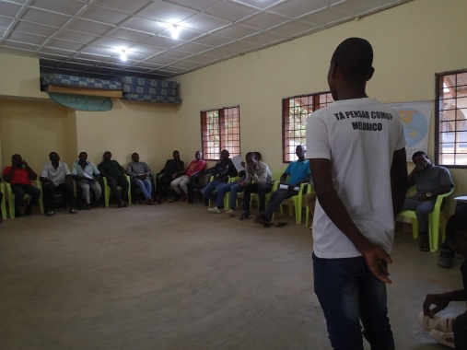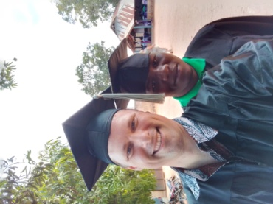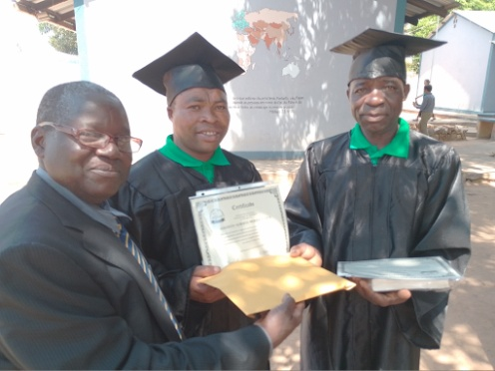

Brother Matias shares Lazaro and Chad Campama, with Augusto and João

at the Timothy Project

Praise God for:

* The 18 graduates and their desire to serve the Lord
* Our safe travels back to Mozambique
* My car trouble happened near my mechanic and not way out in the bush!
* Our new Starlink internet which works even when the cell phone networks are down
* Keeping us safe during the protests

Please Pray for:

* Peace and stability in Mozambique
* My upcoming trip to the church conference in Larde
* The graduates as they continue to minister in their communities
* The upcoming Psalms Seminar and the translation of the 3 Psalms
* Maggie as she is studying at Harding University