Friends and Family,

In my last update I shared about the post election violence that was occurring in Mozambique. Unfortunately this has continued for the past two months and has a huge impact on the entire country. People have protested primarily in the capital city, but also throughout the country. Protestors forced the main border with South Africa to be closed and have targeted many government buildings. Much of this is because the same party has been ruling since 1975, and the last elections were widely condemned as lacking transparency and were neither free nor fair. In reaction to the large scale protests the government asked the national electoral commission to investigate any discrepancies in the voting counts. Normally this might be viewed as an independent organization, however since the same party has been in power for the past 49 years all of the members of this commission are basically puppets of the ruling party. They made their announcement on December 23rd (probably intentionally, knowing things would shut down for the holidays anyway), and the reaction was really strong. On Christmas Eve people burned tires in the streets and we heard sporadic gunfire from police throughout the day. The protests were bigger than ever and since then about 130 protestors were killed by police bringing the total to about 250 people who have been killed so far (primarily by police). Some people seemed to be lighting firecrackers too, so we weren’t sure what were fireworks and what were gunshots.

January 15th is Mozambique’s inauguration day, so we expect things will only continue to escalate in the coming few weeks. Due to this, our family has decided to fly to South Africa this coming Sunday. Many missionaries are currently evacuating in anticipation of the coming violence. We do not feel we are in immediate danger at the moment but we do think it is wise to take this precaution. We had considered driving to Tanzania or Malawi, but there are quite a few road blocks and there is a fuel shortage due to the road blocks. We will be flying out on a small plane from Montepuez with Missionary Aviation Fellowship who will fly us to an airport where we can catch a commercial flight to Johannesburg. We will leave on the 5th and plan to return on the 20th, if things have calmed down. Needless to say, the past week has not been a typical. It has been a mix of a Christmas eve party with friends and an emergency security meeting after Christmas, listening to Christmas music with occasional gun shots, trying to buy extra fuel and last minute Christmas presents, and watching Christmas movies and the latest viral footage of protests.

Despite all this we have had some ministry opportunities over the past few weeks. Early in December we had a Psalms meeting where we translated three more Psalms, which means we have now completed all the Psalms of Ascent (120-134). We also worked on editing all fifteen of these Psalms and are planning to publish them in a small booklet in the near future. (Obviously with the political instability this may not happen as soon as we had hoped.) We also have recorded songs that are participants wrote and correspond with each of these Psalms as well as recordings of the Psalms being read. These we are putting on SD cards that can be played on phones or in radios. This will be our first published booklet of the Psalms we have been translating, so we are excited to see these distributed and used in the churches.

In addition to all this, two weeks ago Cyclone Chido came through and hit Cabo Delgado province. It was a relatively small and fast moving storm that hit a small area really hard. We had some heavy rains and high winds, but nothing too extraordinary. As the storm hit south of us, it did quite a lot of damage to the communities where we work with churches. Closer to the coast whole villages were completely destroyed as their houses collapsed under the strong winds and driving rains. Shortly after the storm I travelled to two communities that were hit particularly hard closer to us. In one refugee community the roofs of multiple buildings had been blown off and the houses had collapsed. Food that was stored inside was soaked and ruined, adding to their difficulties. In another town about half of the houses had some damage and others were hit particularly hard. I visited church members in both of these villages as they tried to rebuild their homes and gave some plastic to help with shelter from the rain. One of the big problems of this cyclone has been the timing, because it is only the beginning of the rainy season and not a good time to be building. Thankfully for about two weeks after the cyclone there was a pause in the rains which allowed people to rebuild or repair their homes. Our teammates, the Smiths were able to distribute food and plastic to the churches in some of the hardest hit areas right before Christmas. (Thankfully there were no roadblocks on the day that did this.)

During our time in South Africa I plan to spend part of that time continuing to write and develop materials that the churches can use. Lord willing, we will be able to return in a few weeks without much disruption to our work here. Our teammates, the Smiths, have decided to wait things out in Montepuez. The Baileys are currently visiting churches in Tanzania, so they may delay their return as well. The Bunches, our school teachers, will also be going to South Africa and staying near us. Our teammate Brooklyn is on furlough in the States. We will be flying out with the Pflederers, the Bible translators that live next to us. The Salyers (our missionary mechanic friend) will also be heading to South Africa. Also some of our friends who have a fruit and veggie business here will continue to stay in town, so the Smiths won’t be totally alone. We are praying that things in the country move toward a peaceful resolution and there will be an end to the violence and we can continue to work here without interference.

Praise God for:

* Protection during the various protests in Montepuez
* Finishing the Psalms of Ascent
* The good weather allowing the cyclone victims to rebuild their homes
* Being able to enjoy some of our normal Christmas traditions despite the chaos
* Being able to fill up my tank with fuel before it ran out.

Please Pray for:

* Peace and justice in Mozambique
* The Smiths as they continue to stay in Montepuez
* The many missionary families currently evacuating Mozambique
* The Cyclone victims as they try to rebuild their homes
* The Psalms of Ascent to be published and have a powerful impact on the church

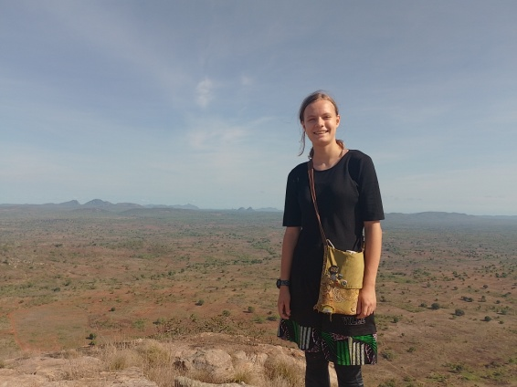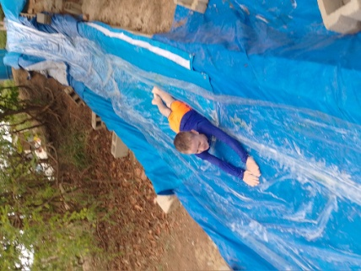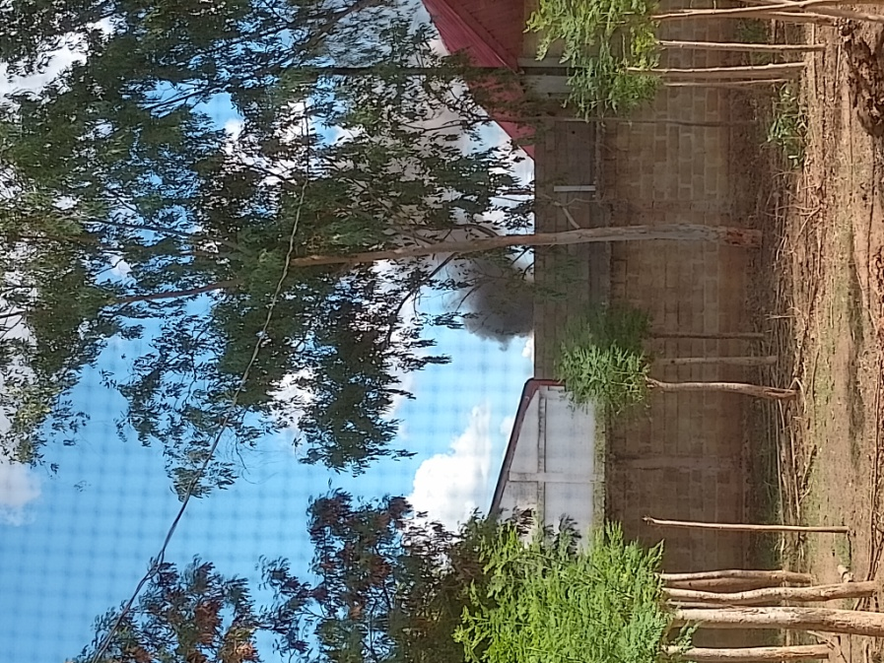

Jane and I hiked a mountain Jack at the Thanksgiving Water Slide Burning Tires on Christmas

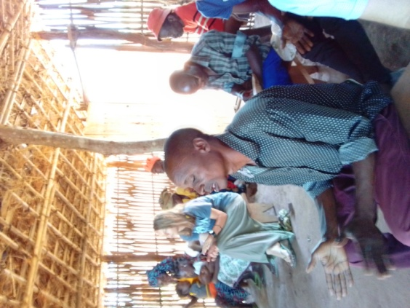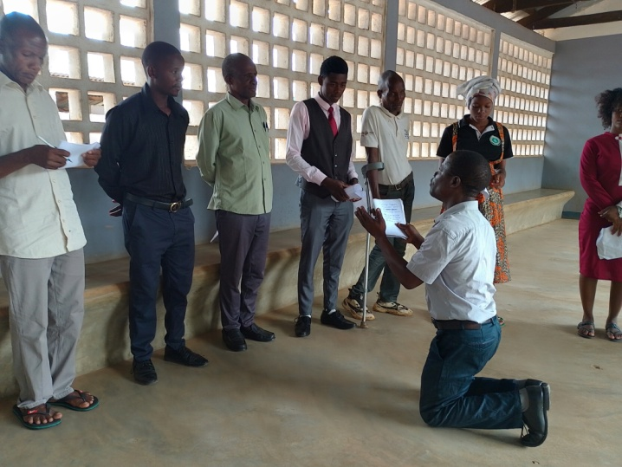

Worshipping with the church in Muaja Acting Out Psalm 132, David Prays to God

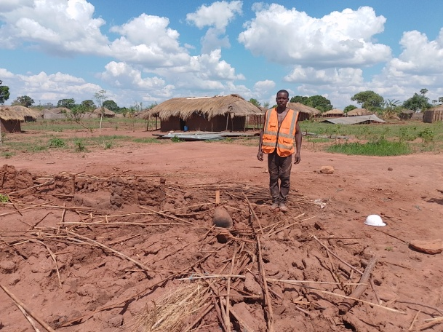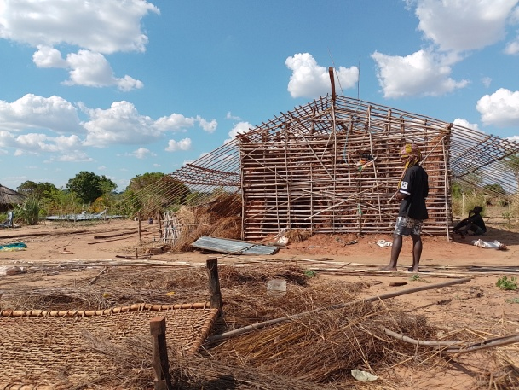

A Refugee Brother Standing by the Ruins A House Damaged by the Storm in Namuno

Of his House (His Roof is in the Background)